**Analysis of YouTuber debate network for 2017-2018**

This report seeks to analyze a network of political YouTubers (19 in total, randomly selected) and how their connections change from the year 2017 to 2018 by tracking the debates and discussions between such YouTubers over the two-year period. An undirected graph was utilized in which the weights assigned to each edge were calculated as follows (same formula for both 2017 and 2018):

Weight = Number of debates/discussions * Total Hours * Total Views * total Like/Dislike ratio

Where Total Hours is the sum of all hours of interactions in video, Total Views is the sum of all the views on the videos in which both YouTubers appear and total Like/Dislike ratio is the sum of all Like/Dislike ratios of each video in which the YouTubers interact for a particular year. Fig 1 shows the Network for the year 2017 and Fig 2 shows the network for the year 2018. In the network we observe that some YouTube channels have 1 (Vaush) or 0 (Dutton and Modern Day Debate) degrees, this is mainly because these channels had very little exposure and content during 2017 but in 2018 they experienced a significant rise in subscriptions and views, which allowed them to gain the attention of more influential and highly connected YouTubers (generally YouTuber collaborations are highly dependent upon the potential new subscribers, donations or channel views that will be acquired from inviting a guest on a particular stream).

From Fig 3 and Table 1 we can see very few nodes have a high BC (Betweenness Centrality) value, in fact there are several nodes that have a BC value of 0, which implies several nodes do not appear in any of the shortest paths between two particular nodes. This is because many YouTubers from sample in 2017 were not really focused on debates but rather making individualized content, the popularization of the YouTube (YT) super-chat system (where live viewers can donate money to YouTubers in real time through YT live chat) occurred mainly in 2018, this might explain why many YouTubers were not interested in hosting debates (less financial incentive) which may have contributed to low BC. However one YouTuber Destiny (who had highest BC value) was involved in online debates for much longer and accumulated links with many YouTubers already, and then those YouTubers found out about each other through following Destiny, which might explain his high BC. This might also explain why Destiny had the highest DC (Degree Centrality) value, he was present for longer, thus accumulated more links than everybody else and hence had the most degrees. Other than Destiny, Warski and Gariepy has the 2nd and 3rd highest DC measure, mainly because they were starting to get involved in debates more intensely by end of 2017, however most nodes have very low DC (Avg Degrees = 3.4) again this could be explained by YouTubers not being interested in hosting debates due to less financial incentive and more focus on independent content.

Regarding CC (Closeness Centrality) we can see the distribution has much less variability than BC distribution. Other than 2 isolated nodes all have a CC value between 0.3 and 1, where majority seem to cluster around range from 0.4 to 0.5. However in this context CC might not be a good measure of how central a node is because, the distance between two nodes does not translate to any real obstacle in communication between YouTubers, a YouTuber with low CC such as Friended will not have a harder time contacting someone like Destiny (highest CC value) than someone with a higher CC value (Gariepy). In fact even though Gariepy has a higher CC value most of the other nodes, it will actually be much harder to get in contact with Destiny because these YouTubers have animosity towards each other.

From Table 1, using EC (Eigenvector Centrality), we can measure how influential a node is within a network. In this case it seems that Destiny (EC of 1) is the most influential node in the network (this can also be substantiated by him having highest BC and DC) and the 2nd and 3rd most influential nodes being Warki (EC of 0.816) and Gariepy (EC of 0.810) respectively. We know Destiny started debating long before 2017, and thus accumulating more links and gaining more notoriety contributing to him being most influential. The influence of Warski and Gariepy maybe attributed to the following: in late 2017 they started moving away from individualized content and focused more on debates and discussions with other YouTubers, as their subscriptions and views grew they focused more on such content to help grow their channel for more possible sponsorship and advertisement opportunities.

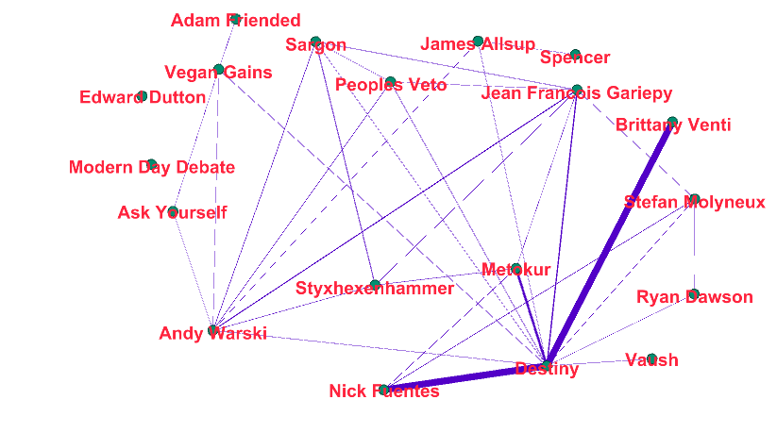 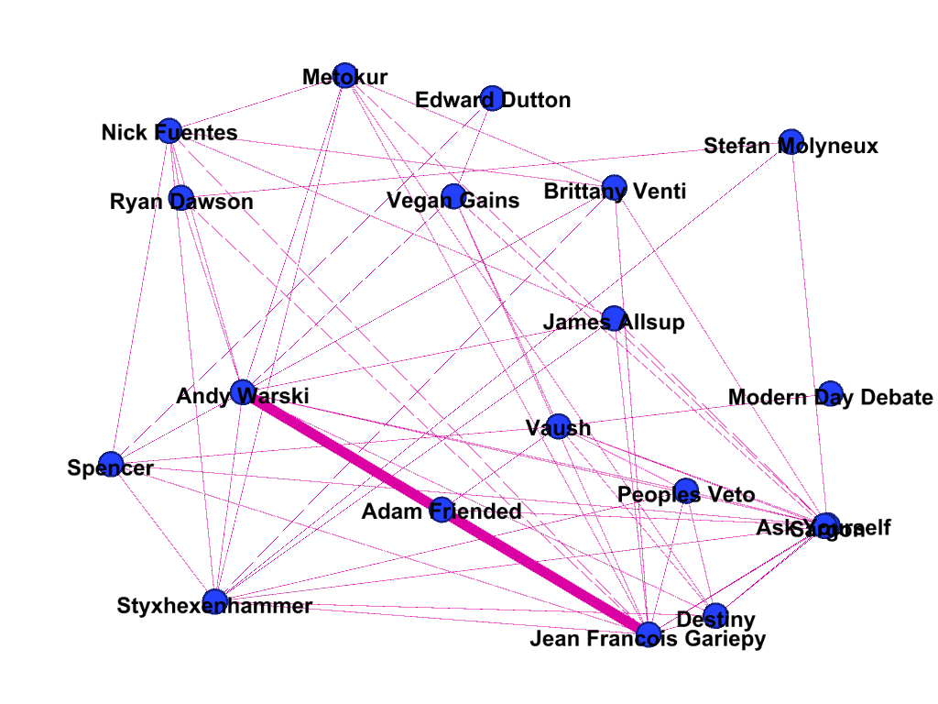

Fig 1. Network for 2017 Fig 2. Network for 2018

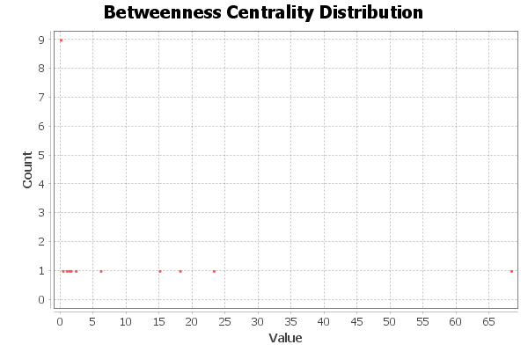 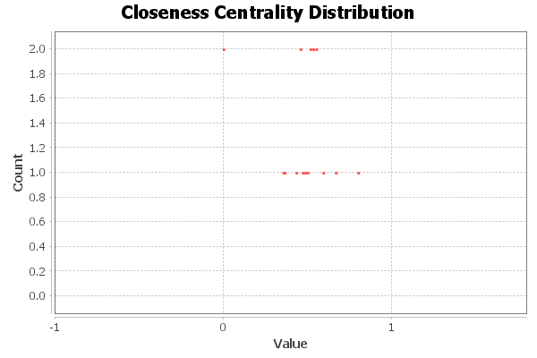

Fig 3. Betweenness Centrality for 2017 Fig 4. Closeness Centrality for 2017, Table 1 below

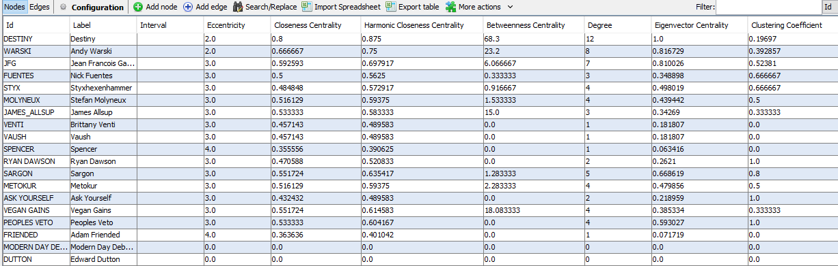

For 2017, the ACC (average clustering coefficient) comes out to be 0.61, which may not be high enough to indicate deliberate formation of clusters but still indicates some kind of clustering is going on, which we may expect to become weaker as we add more YouTubers to the network.

Now we will analyze the same centrality and clustering measures for the year 2018 and assess whether significant changes have occurred or not. From Fig 3(a) we can see distribution for BC is much more varied and Destiny no longer has a disproportionately higher centrality measure than everybody else. In 2018 it seems Sargon has the highest BC measure, followed by Vaush for the 2nd highest. The reason for the substantial decrease in BC for Destiny could be due to the presence of much more well connected people in the network (who have greater than or equal to DC when compared to Destiny) such as Vaush, Styx and Sargon. These and other YouTubers may have experienced significant growth during early 2018 and became more connected through debates thus becoming more central and making Destiny less central. In terms of DC, Density had been displaced by Sargon and Gariepy, whom had highest DC, followed by Warski with 2nd highest. This could be due to the collaboration between Warski and Gariepy for 2018, where they held debates with multiple YouTubers at frequent intervals throughout the year, thus resulting in higher number of degrees. Sargon was also part of many of these debates thus the collaboration between Warski and Gariepy not only affected their degree centrality but also that of their frequently occurring guests (such as Sargon and Styx). The average degree of 2018 was 6.6 which is much higher than that of 2017. Overall we can say YouTubers who were less popular in 2017 became much more popular in 2018.

For EC, we can see that Warski was the most influential within the network, followed closely by both Gariepy and Sargon. Since Gariepy was a co-host on Warski’s channel for most of the year, it’s possible that his value of EC was contributed to by Warski Live show. Similarly Sargon’s high EC value could be due to his frequent appearance on Warski’s show and his extremely popular debate with Richard Spencer, in which multiple YouTubers were present, which gave him the opportunity to connect with more central people, hence enhancing his own EC. We can also see that Styx’s EC improved to 4rd highest and it’s highly likely this was due to his frequent appearance on Warski’s show where he had the opportunity to connect to very central people in the debating sphere. The EC of Destiny fell from 1.0 to 0.716, this could be due to YouTubers not having to rely solely him to become better known in the debating sphere and instead appealing to more influential people like Warski and Gariepy.

We can see the average clustering (ACC) is lower in 2018 (0.57) compared to that of 2017 and this cannot be attributed to increase in number of nodes in the network since the number of nodes remained same, rather it must be due the change in nature of connections that decreased likelihood of clustering in the network. It’s possible that due to more YouTubers being involved in debates means more variety of topics to address hence greater likelihood of disagreement and contention, which could disfavor formation of cliques or clubs hence making clustering harder. There was also much more variability in individual clustering scores for 2018 as compared to 2017. In 2017 we can see from Table 1 majority of scores were very low and only a few were highly scored. However in 2018, we can assess from Table 2 that individual clustering scores took a greater range of values.

Overall we can see there were substantial changes in the network from 2017 to 2018. During 2018, many YouTubers seem to have taken the initiative to debate and focus more on long format response videos and live-streamed discussions, which could explain why the 2018 network has more connections in general and more variable distribution of centrality scores. The YT super-chat system (mentioned earlier), seemed to have made it much more financially profitable to host debates and live-streams and financial success of the Warski show may have been the catalyst for other YouTubers to take a similar route with their content.

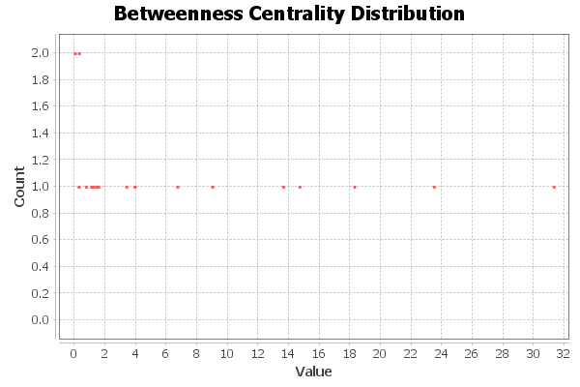

Fig 3(a) Betweenness Centrality for 2018

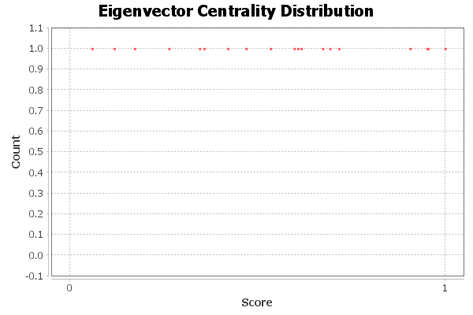

Fig 4(a) Eigenvector Centrality for 2018,

Table 2 below, for 2018

